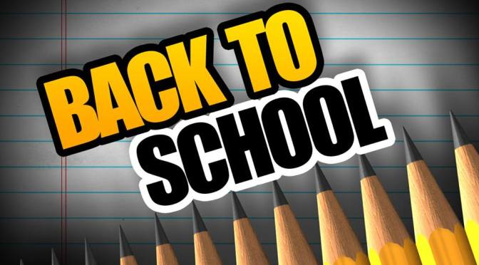
Suggested Supply List
Fifth Grade
The Clark County School District provides the necessary supplies for all students in order to meet their educational needs. However, we know that sometimes parents choose to buy school supplies for their child. The following are the items which would be appropriate for your child’s grade level.
For Students For Classroom
Pencils 1 box facial tissue
Scissors 1 box quart size Ziploc
Glue sticks 1 roll of paper towels
3 Spiral notebooks
2 composition books
1 pencil box
1 ½ inch binder
1 package of white board markers
1 white board eraser/sock
1 package Highlighters yellow, green,pink ,blue
1 box colored pencils 12 pack
1 pair of headphones or earbuds (no air pods)
3 pocket folders with prongs for homework

