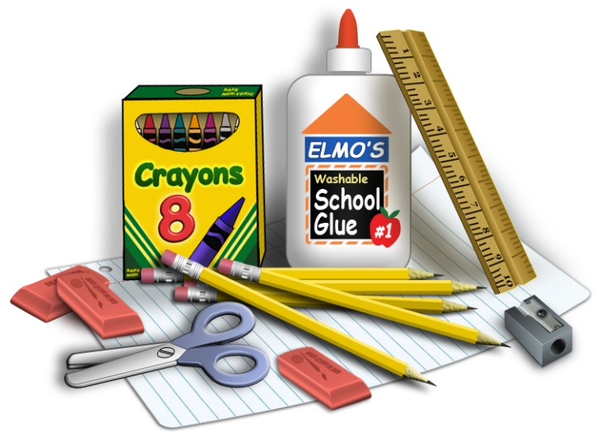
Suggested Supply List
Third Grade

The Clark County School District provides the necessary supplies for all students in order to meet their educational needs. However, we know that sometimes parents choose to buys school supplies for their child. The following are the items which would be appropriate for your child’s grade level.

Needed classroom supplies:
4 spiral notebooks 1 pencil box/bag
2 folders 1 reusable water bottle
1 package of white board markers 2 large pink erasers
1 box of Pencils 1 pair of headphones or earbuds
1 package of index cards 1 box of facial tissue
1 package of sticky notes 2 bottles of hand sanitizer
1 box of colored pencils 1 container Clorox/disinfecting wipes
1 package of Highlighters (at least 2 different colors)

***Please no Trapper Keeper Notebooks or Binders***

